All children have the right to be safe.
On behalf of Goolburri Aboriginal health Advancement Company Limited, I am committed to the safety, wellbeing, cultural safety and empowerment of all children and young people who are supported by our services and programs.
At Goolburri, we live by our values of accountability, quality, teamwork, and confidentiality. These principles help us create a safe, supportive space where we protect human rights and ensure every child and family feels respected, valued, and empowered.
Goolburri acknowledges the central role we play in upholding this right to safety as a lead Aboriginal and Torres Strait Islander agency for preventing abuse and protecting children and young people.
Goolburri welcomes new legislation, Child Safe Organisation Act 2024 (the Act) in
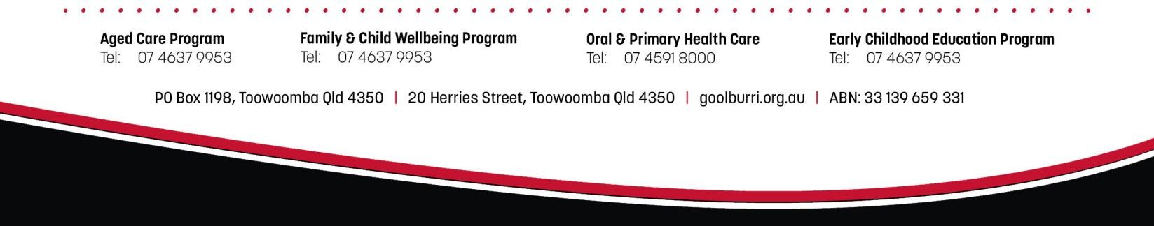

Queensland. The Act requires our organisation to implement the Universal Principle and Child Safe Standards. Goolburri is committed to becoming compliant with the 10 Child Safe Standards and Universal Principle.

Statement of Commitment

to

the
Safety

and Wellbeing

of Children

We have zero tolerance for child abuse. We will treat seriously all allegations and safety concerns, in line with our robust policies and procedures. We will create a culture of safety and follow all legislative and other requirements to report any harm or suspicions of harm to children we support.
Goolburri will be responsive to the needs of all children and young people, including the cultural safety and needs of Aboriginal and Torres Strait Islander children, children from culturally and linguistically diverse backgrounds, children with disability, LGBTQIA+ children, very young children, children with prior trauma and children living in remote locations.
We will ensure that child safety and wellbeing is embedded in our organisational culture, reflected in our policies and procedures, and understood and practiced at all levels of our work.

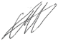

Trent Adams
Deputy Chief Executive Officer

